Market Garden Crop Planner ReadMe

Prepared by Gavin O’Leary on September 26, 2020

# What is this tool and what can it do?

This is a business and operations planning tool designed for consumer-supported agriculture (CSA) farms. The basic business model is that customers buy farm products on a subscription basis, with deliveries being made on a weekly or bi-weekly basis.

This tool attempts to answer the following questions:

1. What can I plant in my area?
2. When should I plant these crops?
3. When will they be ready?
4. How should I price my CSA shares?
5. What is the financial outlook of my farm?

To answer the above questions, this tool performs the following functions:

1. Organize reference data on the Planting Constraints, DS (Direct Seeding) Crop Ref, and TP (Transplant) Crop Ref sheets.
   1. This reference data is going to vary with the local climate conditions. I would recommend reviewing and updating this data if any of the later calculations don’t pass the sniff test.
2. Business planning: On the Annual Input sheet, users can adjust the input parameters (highlighted cells) to model the finances of their farm.
   1. The Planning Period Start and Planning Period End values are by default set to 1 year. If you want to plan out multiple seasons at a time, you may extend this to 2 or more years.
3. CSA Share Modelling: After validating the reference data and clicking the **Recalculate Availability** button on the Intro sheet, the workbook will calculate when your crops will be available (represented by green cells on the Weekly CSA Share Content sheet).
   1. By default, the workbook will order one unit of each available crop. That is, if you’re tracking tomato yield by the pound and your tomatoes are available for 10 weeks in the season, then each CSA share will be allocated 10 pounds of tomatoes.
      1. If the ‘one-of-each’ allocation isn’t practical, you may change then ordered quantity by changing the numbers on the Weekly CSA Share Content sheet. Fractional values are accepted.
   2. As you add and subtract items from your weekly CSA shares, you’ll notice the two summary rows at the bottom of the sheet are keeping track of how much each share is worth. This information is used to calculate the average Weekly CSA Share price in cell B1 of the Annual plan sheet.
4. Farm Operations Planning: Once you have customized your weekly CSA shares, you can click the **Create Farm Plan** button on the Intro sheet to generate a consolidated operations calendar along with seed orders, greenhouse and crop schedules, and weekly harvest targets.
   1. Calendar – This sheet offers a consolidated weekly schedule of Field Prep, Greenhouse, and Field Planting work.
   2. Weekly CSA Harvest Target – This sheet simply multiplies the Weekly CSA Share Content table by the number of shares offered.
   3. Seed Sheet – This sheet calculates the amount of seed needed for each crop this season.
   4. Greenhouse Schedule – This sheet calculates the number of trays each transplanted crop needs in the greenhouse and on what days they should be started.
   5. Crop Sheet – This sheet calculates the planting frequency and quantity for each crop to meet the weekly harvest targets.
   6. Field Ops – This sheet calculates the field prep dates for the various planting groups outlined in the Crop Sheet.
   7. Field Planting Schedule – This sheet provides weekly summaries of the amount of planting needed to meet the weekly harvest targets. Mostly, it is used in the Crop Sheet calculations.

If you have any questions about how this tool functions or the code it uses, reach out to Gavin O’Leary on the Permies.com forums.

If you want to learn more about market gardening, these two books inspired much of the design and layout of this tool:

1. [The Market Gardener](https://www.themarketgardener.com/book) – Jean-Martin Fortier
2. [Crop Planning for Vegetable Growers](https://cog-shop.myshopify.com/products/crop-planning-for-vegetable-growers) - Frederic Theriault & Daniel Brisebois

# How to use this workbook

## Make sure your Reference Data is up to date

Every decision that this tool supports is going to be driven by the reference data that is loaded into it. If the planting constraints or days-to-maturity parameters don’t fit your site, then the plan will not reflect your garden’s performance. Garbage in, garbage out.

1. Go through each green-tabbed sheet in the workbook and check whether any of the pre-loaded data reflects your local environment. By default, this tool is configured to model the humid-subtropical climate of Louisville, Kentucky

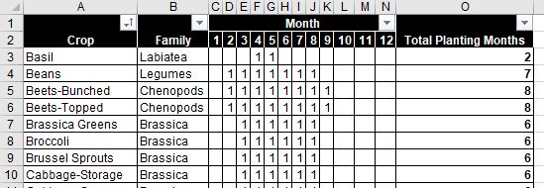

Figure 1 The Planting Constraints table

1. Planting Constraints – For each crop that you want to plant, this table tracks whether it can be planted in each month with a 1 or 0. Double check this against your own experience and local knowledge.

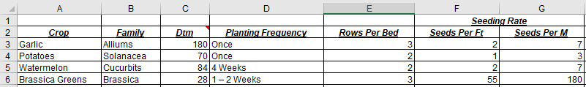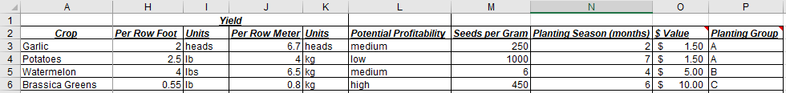

Figure 2 The DS Crop Ref table

1. DS Crop Ref – For each directly-seeded crop that you want to plant, this table tracks the following info. Amend as needed for your own site.
   1. Crop: Name of the crop
   2. Family: Family of the crop
   3. Dtm: Days to maturity (ie. How long from planting to harvest)
   4. Planting Frequency: How often you want to plant each crop per season.
      1. Where a range is given (eg. 2 - 4 weeks), the tool will use the longer planting interval (4 weeks).
   5. Rows Per Bed: How many rows of this crop you want to plant in a single bed
   6. Seeds Per Ft: How many seeds are needed per row-foot
   7. Seeds Per Meter: How many seeds are needed per row-meter
   8. Yield Per Row Foot: Estimated harvest yield per row-foot
   9. Units Per Row Foot: Unit of measurement for the yield per row-foot (heads, lbs, etc.)
   10. Yield Per Row Meter: Estimated harvest yield per row-meter
   11. Units Per Row Meter: Unit of measurement for the yield per row-meter (heads, kg, etc.)
   12. Potential Profitability: Your own estimate of how profitable this crop is per acre planted
   13. Seeds Per Gram: Size of the seed, used to help estimate your seed bill later
   14. Planting Season (months): How many months in which this crop can be planted
   15. $ Value: Dollar value you will charge for 1 unit of crop yield ($ per lb, $ per bunch, etc.)
   16. Planting Group: Crops are grouped according to family, planting frequency, nutrient requirements, etc.

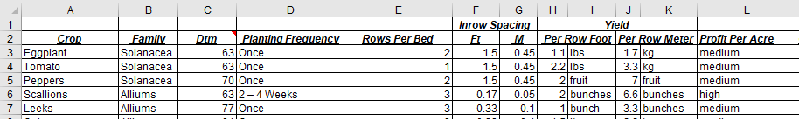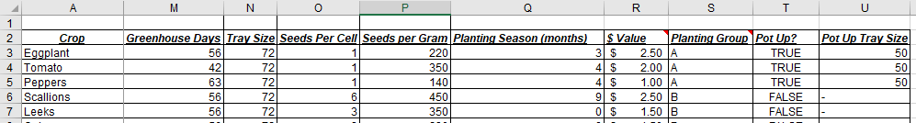

Figure 3 The TP Crop Ref table

1. TP Crop Ref – For each transplanted crop that you want to plant, this table tracks the following info. Amend as needed for your own site.
   1. Crop: Name of the crop
   2. Family: Family of the crop
   3. Dtm: Days to maturity (ie. How long from planting to harvest)
   4. Planting Frequency: How often you want to plant each crop per season.
      1. Where a range is given (eg. 2 - 4 weeks), the tool will use the longer planting interval (4 weeks).
   5. Rows Per Bed: How many rows of this crop you want to plant in a single bed
   6. Inrow Spacing (Ft): How many row-feet you need between plantings
   7. Inrow Spacing (M): How many row-meters you need between plantings
   8. Yield Per Row Foot: Estimated harvest yield per row-foot
   9. Units Per Row Foot: Unit of measurement for the yield per row-foot (heads, lbs, etc.)
   10. Yield Per Row Meter: Estimated harvest yield per row-meter
   11. Units Per Row Meter: Unit of measurement for the yield per row-meter (heads, kg, etc.)
   12. Profit Per Acre: Your own estimate of how profitable this crop is per acre planted
   13. Greenhouse Days: How many days a crop needs to spend in a greenhouse before transplanting
   14. Tray Size: Cell count for your greenhouse tray
   15. Seeds Per cell: How many seeds you should plant per tray cell
   16. Seeds Per Gram: Size of the seed, used to help estimate your seed bill later
   17. Planting Season (months): How many months in which this crop can be planted
   18. $ Value: Dollar value you will charge for 1 unit of crop yield ($ per lb, $ per bunch, etc.)
   19. Planting Group: Crops are grouped according to family, planting frequency, nutrient requirements, etc.
   20. Pot Up: Whether you want to pot up the crop while it is in the greenhouse
   21. Pot Up Tray Size: Cell count for your potted-up greenhouse trays
2. After you’re satisfied with the data on these three sheets, you can begin drafting your garden plan.

## Populate CSA Content

On the Intro tab of this tool, you can begin planning your weekly CSA share content by clicking the Populate CSA Content button.

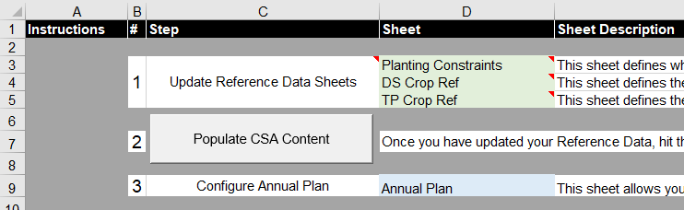

Figure 4 Populate CSA Content button

1. This will fill out the Weekly CSA Share Content tab of the tool with a table of crops and dates. The cells in this table are highlighted according to the availability of a crop in that week, with green cells indicating available crops.

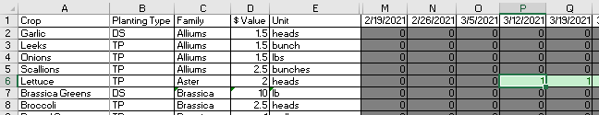

Figure 5 This table indicates that lettuce will be available for harvest by March 12, 2021.

1. By default, the tool will auto-populate every green cell with a 1, indicating how many units of each crop to include in each CSA share. In Fig 5, the tool is planning to give 1 head of lettuce to each CSA share on March 12, 2021. You can change these values yourself to customize your CSA share offerings.

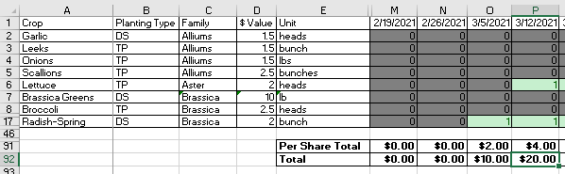

Figure 6 The tool will also calculate the weekly value of your CSA shares

1. At the bottom of the page, there are two rows calculating the per-share value and total value of your weekly CSA offerings. In the above example, our March 12 share is worth $4 and we’re offering 5 shares for a total income of $20.
2. Once you have a rough idea of what you want to offer in your CSA, you’re ready to review the Annual Plan for your business.

## Review the Annual Plan

On the Annual Plan tab, we can model the long-term financial health of our business and simulate different growth and investment plans.

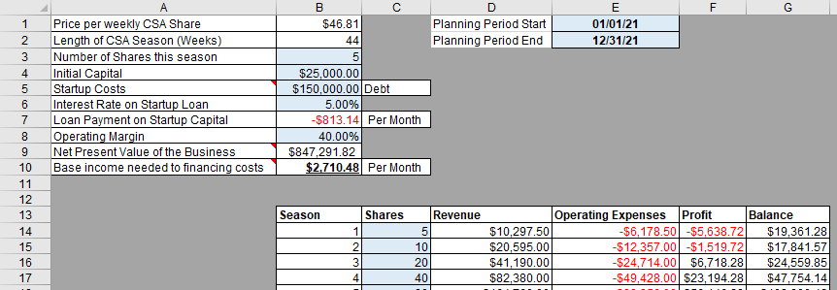

Figure 7 The Annual Plan for our CSA



Figure 8 Date controls

1. First off, you’ll see the planning period outlined in cells E1 & E2. By amending these dates and clicking the Populate CSA Content button on the Intro tab, you can shrink, extend, or change the planning period for your CSA season.

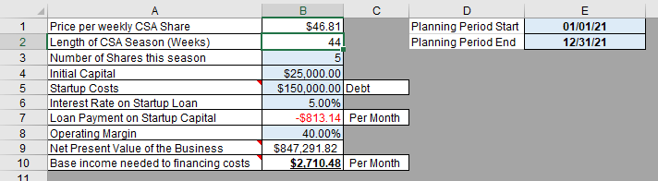

Figure 9 Annual Plan parameters

1. In the upper-left corner of the sheet, we have a variety of calculated and user-defined parameters which are used in the model.
   1. **Price per weekly CSA Share:** This cell is calculated as the average value of every weekly CSA share according to the content you allocated earlier.
   2. **Length of CSA Season (Weeks):** This cell is calculated as the number of weeks in which you’re offering at least one item in your CSA shares.
   3. **Number of Shares this season:** This cell allows you to change the number of CSA shares you’ll offer each week.
   4. **Initial Capital:** How much cash-on-hand you will be starting this venture with
   5. **Startup Costs:** How much you will need to spend to purchase the land & equipment for this venture. Cell C5 allows you to switch between financing this via debt (like a mortgage on a farm) or via equity (from your savings).
   6. **Interest Rate on Startup Loan:** If you are financing your venture with debt, this cell lets you customize the interest rate that you are paying on that loan.
   7. **Loan Payment on Startup Capital:** This cell calculates the payment on any debt financing. Cell C7 allows you to switch between monthly or annual periods.
   8. **Operating Margin**: This cell allows you to model your operating margins. By default, it estimates that 60% of your income will go towards operating costs (seeds, labor, fuel, etc.) and 40% will be profit.
   9. **Net Present Value of the Business:** This field is calculated as the sum of all your annual profits for the next 30 years, discounted back to the present using the interest rate specified in cell B6.
      1. [NPV explained](https://www.investopedia.com/terms/n/npv.asp)
   10. **Base income needed to cover financing costs:** This field calculates the monthly or annual income you’ll need to cover the costs of financing. By default, the tool estimates that 30% of your income must go to mortgage / loan payments.

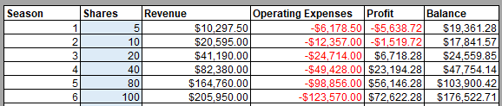

Figure 10 The long-term growth table

1. This table allows you to lay out the year-on-year growth plan for your business (up to 30 years).
   1. **Season:** CSA planning season. Season 1 = this upcoming season.
   2. **Shares:** How many CSA shares you want to offer in a Season.
   3. **Revenue:** Calculated as [Price per weekly CSA Share] * [Length of CSA Season].
   4. **Operating Expenses:** Calculated as [Revenue] * (1 – [Operating Margin])
   5. **Profit:** Calculated as [Revenue] – [Operating Expenses]
   6. **Balance:** Calculated as the previous season’s [Balance] (or your [Initial Capital] for season 1) plus the [Profit] from this current season.
2. Once you’re happy with your Annual Plan, you’re ready to generate your Farm Plan.

## Generate Farm Plan

The Farm Plan will lay out the field prep, greenhouse, and planting schedules needed to support the CSA offerings outlined earlier. To generate it, click the Create Farm Plan button on the Intro tab.

### The Calendar

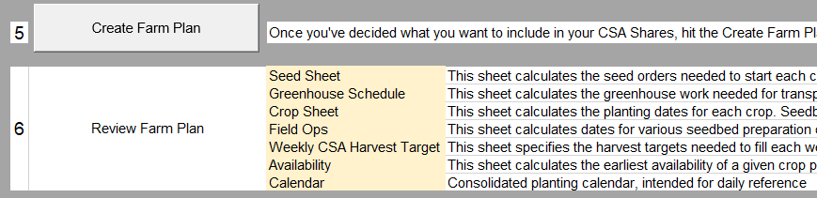

Figure 11 The Create Farm Plan button

As soon as the macro finishes, you’ll be directed to the Calendar tab.

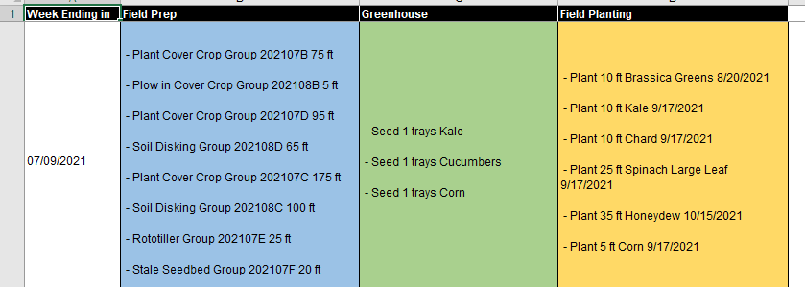

Figure 12 A row from the Calendar table

1. The Calendar tab summarizes everything which will be discussed in the following tabs. Currently, it has 4 columns.
   1. **Week Ending in** – The date by which you should complete this week’s tasks.
   2. **Field Prep –** This column contains all field preparation tasks planned for this week.
   3. **Greenhouse** – This column contains all greenhouse tasks planned for this week.
   4. **Field Planting** – This column contains all planting tasks planned for this week.

### The Weekly CSA Harvest Targets

All the tasks planned on the calendar are driven by your weekly harvest targets, which are in turn driven by your Weekly CSA Share Content tab.

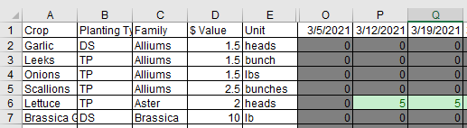

Figure 13 The Weekly CSA Harvest Target table

The Weekly CSA Harvest Target tab is the same as your Weekly CSA Share Content tab, only multiplied by the number of shares you’ve decided to offer this season. In the above example, we are targeting to harvest 5 heads of lettuce on March 12, 2021.

### The Crop Sheet

Once the tool has determined your weekly harvest targets, it calculates the planting dates for each crop. This is calculated on the Crop Sheet tab.

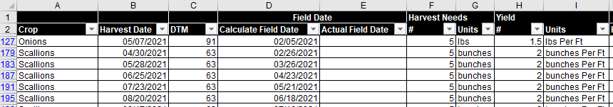 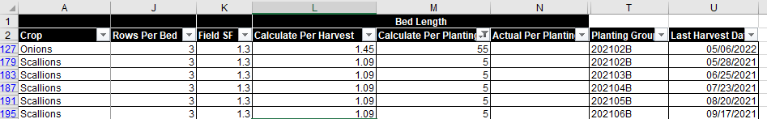

Figure 14 The Crop Sheet

1. The Crop Sheet uses the following columns for its calculations
   1. **Crop** – Name of the crop
   2. **Harvest Date –** A harvest date taken from the Weekly CSA Harvest Target tab.
   3. **DTM –** Days to Maturity, taken from either the DS or TP Crop Ref Sheet tabs.
   4. **Calculate Field Date –** When you should plant the crop in the field. Calculated as [Harvest Date] – [DTM]
   5. **Actual Field Date –** Left blank so that you can put in your own Field Date if it differs from the calculated value.
   6. **Harvest Needs # -** Number representing your harvest target
   7. **Harvest Needs Units –** Units for this harvest target
   8. **Yield # -** Numeric crop yield
   9. **Yield Units –** Yield expressed in units per row-ft
   10. **Rows Per Bed –** How many rows can be planted in a single bed. Taken from either the DS or TP Crop Ref Sheet tabs.
   11. **Field SF –** Field safety factor. Currently set at 1.3 to allow for 30% crop loss rate.
   12. **Calculated Bed Length per Week –** Bed Length (in ft) needed to meet this week’s harvest target. Calculated as ([Field SF] * [Harvest Target]) / ([Yield] * [Rows per Bed])
   13. **Calculated Bed Length Per Planting –** Bed Length (in ft) calculated for this planting. Calculated using the crop planting frequency to determine how many weeks of harvest one planting should yield.
   14. **Actual Bed Length Per Planting –** Leftblank so that you can put in your own planting length if it differs from the calculated value.
   15. **Planting Group –** The workbook groups plantings by month and crop group. This will be used by the Field Ops sheet to organize sections of your garden.
   16. **Last Harvest Date** – This field is calculated as the last harvest date for this planting.

From the data generated by the Crop Sheet tab, we can then create the Greenhouse Schedule, Seed Sheet, and Field Ops tabs.

### The Greenhouse Schedule

For transplanted crops, you will need to start them in the greenhouse before moving them to the field. This sheet will help you coordinate your greenhouse activities.

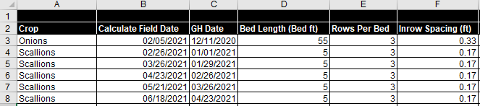

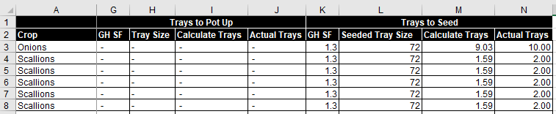

Figure The Greenhouse Schedule table

1. This table will tell you when to start your trays and how many you’ll need to meet your field planting targets. To do this, it uses the following fields:
   1. **Crop –** Name of the crop
   2. **Calculated Field Date –** When you need to plant this crop in the field
   3. **GH Date –** When you need to start this crop in the greenhouse
   4. **Bed Length –** How many bed ft of this crop you’ll need to plant in the field
   5. **Rows Per Bed –** How many rows can be planted per bed
   6. **Inrow Spacing (ft) –** How far apart your plantings should be within rows
   7. **Pot Up GH SF –** TheGreenhouse Safety factor for potting up, set as 1.3 to account for 30% seedling failure at the pot-up stage.
   8. **Pot Up Tray Size –** How many cells are in a pot-up tray for this crop
   9. **Pot Up Calculated Trays –** How many pot-up trays are needed for this crop
   10. **Pot Up Actual Trays –** Calculated Pot Up Trays rounded up to the nearest whole number
   11. **Seeding GH SF –** TheGreenhouse Safety factor for seeding, set as 1.3 to account for 30% seedling failure at this stage.
   12. **Seeding Tray Size –** How many cells are in a seeding tray for this crop
   13. **Seeding (Calculated Trays) –** How many seeding trays are needed for this crop
   14. **Seeding (Actual Trays) –** Calculated Seeding Trays rounded up to the nearest whole number

### The Seed Sheet

This sheet calculates the seed bill that you’ll need to plant everything this season

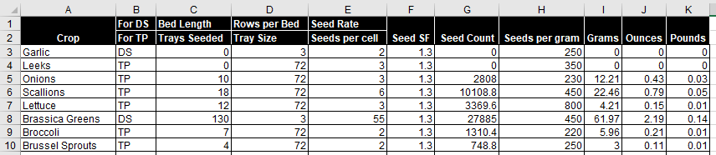

Figure 16 The Seed Sheet

1. To prepare your seed bill, this sheet uses the following fields
   1. **Crop –** Name of each crop
   2. **For DS/TP –** Whether this crop is directly seeded or transplanted
   3. **Bed Length / Trays Seeded –** How many bed-ft or trays are needed for this crop this season.
   4. **Rows per Bed / Tray Size –** How many rows per bed or cells per tray this crop needs
   5. **Seed Rate / Seeds Per Cell –** How many seeds per foot or seeds per cell are needed
   6. **Seed SF –** Safety factor of 1.3 in case of seed failures
   7. **Seed Count –** Calculation of how many seeds you need for this season. Product of the previous 4 fields.
   8. **Seeds per gram –** Taken from the DS or TP Crop Ref Sheet tabs
   9. **Grams –** How many grams of seed are needed this season
   10. **Ounces –** How many ounces of seed are needed this season
   11. **Pounds** – How many pounds of seed are needed this season

### The Field Ops table

This tab is designed to help you plan your field preparation tasks by breaking up your garden into planting groups based on what plants you’re planting when. For example: planting group 202102B corresponds to all Group B crops you’re going to plant in February of 2021. In your own garden, you can assign each planting group to its own strip of soil, or you can save space by overlapping and re-using ground from other planting groups as they become available.

Please treat these operations more as guidelines than as hard-and-fast rules. Every gardener is going to have their own preferred soil management system so feel free to omit or modify any tasks which are generated by this tool. You know your soil better than I do!

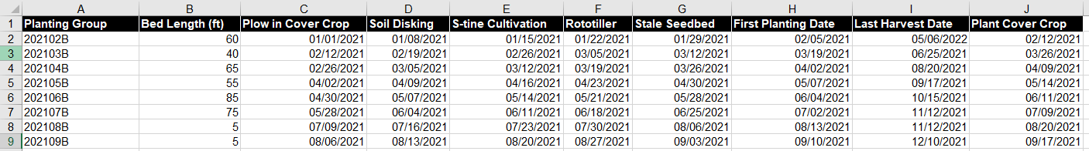

Figure The Field Ops table

1. The Field Ops table records the following information for each planting group
   1. **Planting Group –** The name of each planting group
   2. **Bed Length –** How many feet of bed each planting group needs
   3. **Plow in Cover Crop –** When you should plow in any cover crops on this bed (5 weeks before planting)
   4. **Soil Disking –** Whenyou should disk this bed’s soil (4 weeks before planting)
   5. **S-tine Cultivation –** When you should cultivate this bed’s soil (3 weeks before planting)
   6. **Rototiller –** When you should run a rototiller through this bed’s soil (2 weeks before planting)
   7. **Stale Seedbed –** When you should expose the seedbed and remove any weeds which may have sprouted (1 week before planting)
   8. **First Planting Date –** When the first crops in this planting group must go into the soil
   9. **Last Harvest Date –** When you will harvest the last crops from this planting group
   10. **Plant Cover Crop –** When you should plant in a cover crop to preserve the soil until next planting (1 week after last harvest)

## Resetting the workbook

If you want to return the workbook to its original blank state, then click the Reset Workbook button on the Intro tab. This will remove everything except for the green reference data tabs, so please back up any plans or tables you want to keep to another excel file before proceeding with the reset.

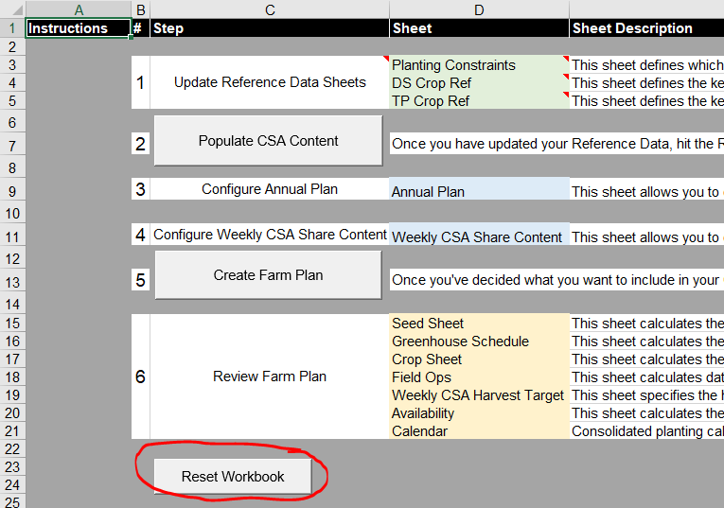

Figure The Reset Button. Handle with care!